Data Models

✅ What is a Data Model?
# Source: AI Source: Provided by: [Data Path: Persons Table -> ID Column: 1, Name_En Column: Motasem Essam] -> From: [ChatGPT] on [6/10/2026]
A data model is a conceptual framework that defines how data is structured, stored, organized, and accessed in a database system.

🔹 In Simple Terms:
# Source: AI Source: Provided by: [Data Path: Persons Table -> ID Column: 1, Name_En Column: Motasem Essam] -> From: [ChatGPT] on [6/10/2026]
A data model is like a blueprint for your data — it tells you:
- What kind of data you have
- How it's connected
- How it can be stored and retrieved

🧱 Why Data Models Are Important
# Source: AI Source: Provided by: [Data Path: Persons Table -> ID Column: 1, Name_En Column: Motasem Essam] -> From: [ChatGPT] on [6/10/2026]
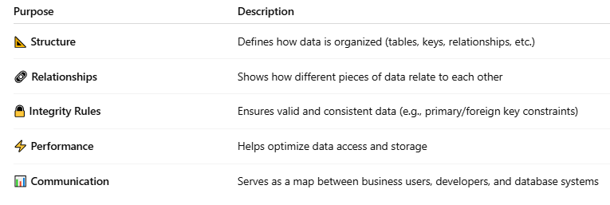
Purpose | Description
📐 Structure | Defines how data is organized (tables, keys, relationships, etc.)
🔗 Relationships | Shows how different pieces of data relate to each other
🔒 Integrity Rules | Ensures valid and consistent data (e.g., primary/foreign key constraints)
⚡ Performance | Helps optimize data access and storage
📊 Communication | Serves as a map between business users, developers, and database systems

🧩 Components of a Data Model
# Source: AI Source: Provided by: [Data Path: Persons Table -> ID Column: 1, Name_En Column: Motasem Essam] -> From: [ChatGPT] on [6/10/2026]
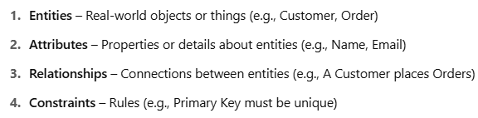
- Entities – Real-world objects or things (e.g., Customer, Order)
- Attributes – Properties or details about entities (e.g., Name, Email)
- Relationships – Connections between entities (e.g., A Customer places Orders)
- Constraints – Rules (e.g., Primary Key must be unique)

🔍 Levels of Data Models
# Source: AI Source: Provided by: [Data Path: Persons Table -> ID Column: 1, Name_En Column: Motasem Essam] -> From: [ChatGPT] on [6/10/2026]
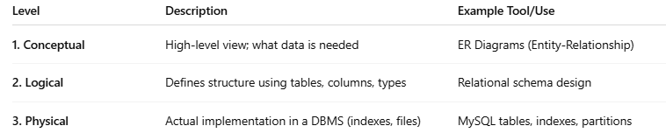
Level | Description | Example Tool/Use
1. Conceptual | High-level view; what data is needed | ER Diagrams (Entity-Relationship)
2. Logical | Defines structure using tables, columns, types | Relational schema design
3. Physical | Actual implementation in a DBMS (indexes, files) | MySQL tables, indexes, partitions

🧭 Types of Data Models
# Source: AI Source: Provided by: [Data Path: Persons Table -> ID Column: 1, Name_En Column: Motasem Essam] -> From: [ChatGPT] on [6/10/2026]
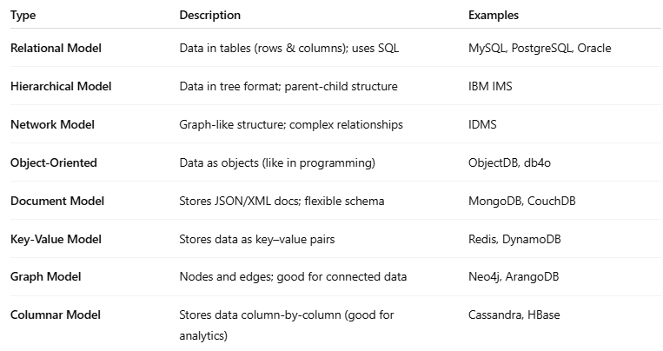
Type | Description | Examples
Relational Model | Data in tables (rows & columns); uses SQL | MySQL, PostgreSQL, Oracle
Hierarchical Model | Data in tree format; parent-child structure | IBM IMS
Network Model | Graph-like structure; complex relationships | IDMS
Object-Oriented | Data as objects (like in programming) | ObjectDB, db4o
Document Model | Stores JSON/XML docs; flexible schema | MongoDB, CouchDB
Key-Value Model | Stores data as key–value pairs | Redis, DynamoDB
Graph Model | Nodes and edges; good for connected data | Neo4j, ArangoDB
Columnar Model | Stores data column-by-column (good for analytics) | Cassandra, HBase

🔸 Visual Summary
# Source: AI Source: Provided by: [Data Path: Persons Table -> ID Column: 1, Name_En Column: Motasem Essam] -> From: [ChatGPT] on [6/10/2026]
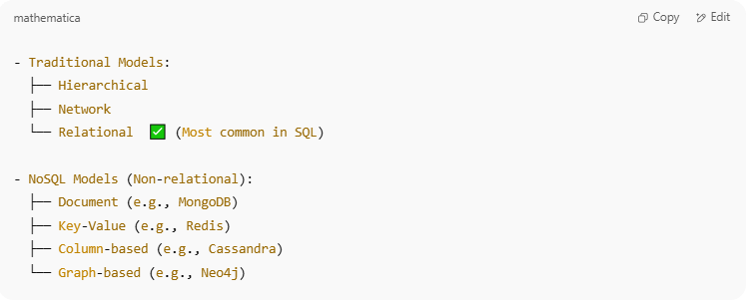
- Traditional Models:
├── Hierarchical
├── Network
└── Relational ✅ (Most common in SQL)

- NoSQL Models (Non-relational):
├── Document (e.g., MongoDB)
├── Key-Value (e.g., Redis)
├── Column-based (e.g., Cassandra)
└── Graph-based (e.g., Neo4j)

📘 Example from a Relational Data Model

Entity: Customers
# Source: AI Source: Provided by: [Data Path: Persons Table -> ID Column: 1, Name_En Column: Motasem Essam] -> From: [ChatGPT] on [6/10/2026]
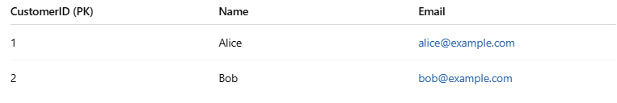
CustomerID (PK) | Name | Email
1 | Alice | alice@example.com
2 | Bob | bob@example.com

Entity: Orders
# Source: AI Source: Provided by: [Data Path: Persons Table -> ID Column: 1, Name_En Column: Motasem Essam] -> From: [ChatGPT] on [6/10/2026]
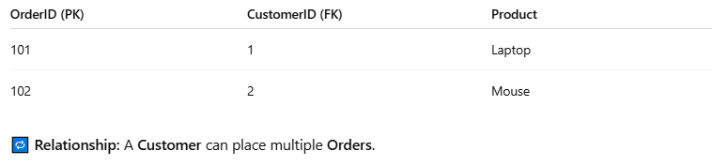
OrderID (PK) | CustomerID (FK) | Product
101 | 1 | Laptop
102 | 2 | Mouse
🔁 Relationship: A Customer can place multiple Orders.

